Name: _____________________________
Full Test (Sections 1 and 2)

Total Time: 57 minutes

Total Marks: 50 marks

Student Result ________/ 50

MATHEMATICS METHODS Unit 3/4
TEST 3 -2021: Logarithmic Functions, Continuous Random Variables

Calculator Free Section
Time: 27 minutes
Total Marks: ______ / 24 marks

Resources allowed: SCSA Formula Sheet

Instructions to candidates
Show all your working clearly. Your working should be in sufficient detail to allow your answers to be checked readily and for marks to be awarded for reasoning. Incorrect answers given without supporting reasoning cannot be allocated any marks. For any question or part question worth more than two marks, valid working or justification is required to receive full marks. If you repeat any question, ensure that you cancel the answer you do not wish to have marked.

Question 1 | [2, 2 = 4 marks]

Evaluate each of the following.

a) $\log_{3}{81}+\ln\left(\frac{1}{e^{2}}\right)$

b) $\log_{5}{75}+\log_{5}{10}-\log_{5}{6}$

Question 2 | [2 marks]

Express $2-\log{p}+3\log{q}$ as a single logarithm.

Question 3 | [2 marks]

Solve $1200=150e^{0.25x}$, for $x$.

Question 4 | [2, 2 = 4 marks]

Find $\frac{dy}{dx}$ for each of the following.

a) $y=x^{2}\ln{(2x^{3})}$

b) $y =\ln\left(\frac{{4x}^{2}}{x-3}\right)$

Question 5 | [4 marks]

Below is the graph of $f(x)=\frac{10}{1+5x}-1$.

Determine the shaded area trapped between the positive axes and $f(x)$.
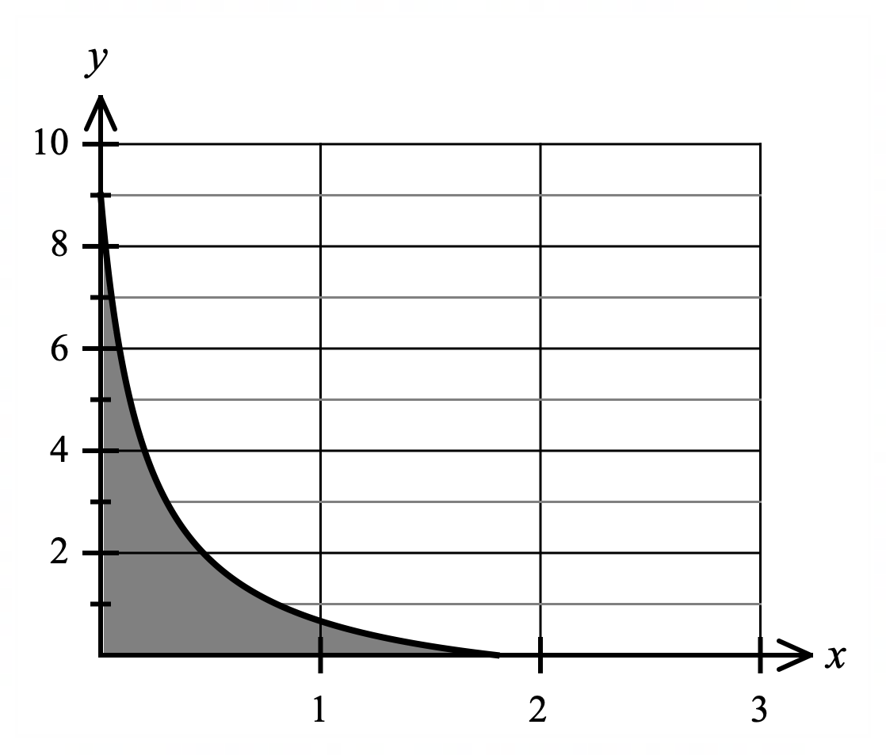

Question 6 | [2, 1, 3, 2 = 8 marks]

A continuous random variable, $X$, has a probability density function given by that below.

$p\left(x\right)=\left\{\begin{matrix}\frac{q}{x} \\ 0\end{matrix}\right. \begin{matrix} for 1≤x≤5 \\ elsewhere\end{matrix}$

a) Show that the value for the constant $q=\frac{1}{\ln{5}}$.

b) Determine $P(X=4)$

c) Determine $P(2<X<4)$

d) Determine the expected value, $E(X)$, for this continuous random variable.

End of Calculator Free Section

Name: _____________________________

MATHEMATICS METHODS Unit 3/4
TEST 3 -2021: Logarithmic Functions, Continuous Random Variables

Calculator Assumed Section
Time: 30 minutes
Total Marks: ______ / 26 marks

Resources allowed:
SCSA Formula Sheet
Up to three Calculators and
One A4 sheet, both sides of notes

Instructions to candidates
Show all your working clearly. Your working should be in sufficient detail to allow your answers to be checked readily and for marks to be awarded for reasoning. Incorrect answers given without supporting reasoning cannot be allocated any marks. For any question or part question worth more than two marks, valid working or justification is required to receive full marks. If you repeat any question, ensure that you cancel the answer you do not wish to have marked.

Question 7 | [2, 2, 2 = 6 marks]

The probability density function that models the likely length of time, in minutes, between meteors (shooting stars) being seen during a meteor shower is given below.

$p(x)=\left\{\begin{matrix}0.8e^{-0.8x} \\ 0\end{matrix}\right. \begin{matrix}for x>0 \\ elsewhere\end{matrix}$

a) Show that the probability of two meteors being seen within 1 minute of each other is approximately 0.5507.

b) Determine the probability that it takes more than 5 minutes between two consecutive meteors being seen.

c) Determine the expected time, or long term average, between meteors during the meteor shower.

Question 8 | [2, 3 = 5 marks]

The velocity, $v$ ms⁻¹, of a particle P moving in a straight line, at time $t$ seconds, from a fixed origin O, is given by:

$v=\frac{2}{(t+3)}$ , for $t≥0$.

- Comment on the nature of the velocity of the particle for $t≥0$.

- If the particle initially has a displacement of $x=\left(\ln{3}\right)$ metres, show that the displacement at any time $t≥0$, from the fixed origin O, is given by:

$x=\ln{\frac{{\left(t+3\right)}^{2}}{3}}$

Question 9 | [2, 2, 3 = 7 marks]

The ear has the remarkable ability to handle an enormous range of sound levels. In order to express levels of sound meaningfully in numbers that are more manageable, a logarithmic scale is used, rather than a linear scale. This scale is the decibel (dB) scale.

The sound intensity level, $L$, is given by the formula below:

$L=10\log\left(\frac{I}{I_{0}}\right)$ dB where $I$ is the sound intensity and $I_{0}$ is the reference sound intensity.

$I$ and $I_{0}$ are measured in watt/m².

- Listening to a sound intensity of 1.26 billion times that of the reference intensity for more than 2 hours is considered unsafe. To what sound intensity level, $L$, does this correspond?

- The reference sound intensity, $I_{0}$, has a sound intensity level of 0 dB. If a petrol chainsaw has a sound intensity, $I=1×{10}^{-1}$ watt/m² and this corresponds to a sound intensity level of 110 dB, determine $I_{0}$ in watt/m².

The distance from a sound source, $r$, will affect sound intensity, $I$, according to the following relationship.

$$\frac{I_{2}}{I_{1}}={\left(\frac{r_{1}}{r_{2}}\right)}^{2}$$

A jet taking off at 300 metres away typically reaches 100 dB.

c) Calculate the sound intensity level, $L$ in dB, a jet take-off will typically reach at 1 km away.

Question 10 | [2, 3, 1, 2 = 8 marks]

A continuous random variable $X$, has the following probability density function.

$p\left(x\right)=\left\{\begin{matrix}kx^{3} \\ 0\end{matrix}\right. \begin{matrix}1≤x≤3 \\ elsewhere\end{matrix}$

a) Show that the value of $k=\frac{1}{20}$.

b) Determine the cumulative density function for the continuous random variable $X$.

The mean or expected value for the continuous random variable $X$ is $E\left(X\right)=2.42$.

c) Determine the value of $Var(X)$, correct to 4 decimal places.

A second continuous random variable $Y$, is defined as $Y=3X+2$.

d) Determine, correct to 2 decimal places, the value of:

i). $E(Y)$

ii). $Var(Y)$

End of Test

